

**Tribhuvan University**

**Faculty of Humanities and Social Sciences**

DOT NET LABSHEETS

A PROJECT REPORT

Submitted to

Department of Computer Application

Shahid Smarak College

*In partial fulfillment of the requirements for the Bachelors in Computer Application*

Submitted by: -

Amir Maharjan

**Internal supervisor**

Rajesh Shahi Thakuri

# External Supervisor

**Problem – 1**

Write a program to implement the concept of default constructor, parameterized constructor

**Code**

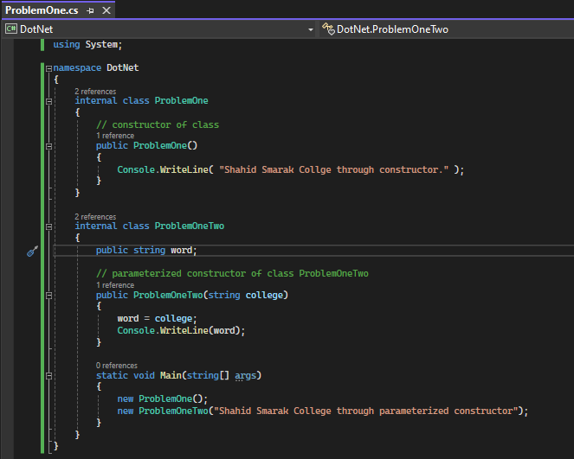

**Result**

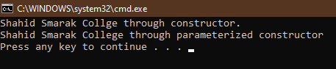

**Problem – 2**

Write a program to implement the concept to operator (+) overloading (binary)

**Code**

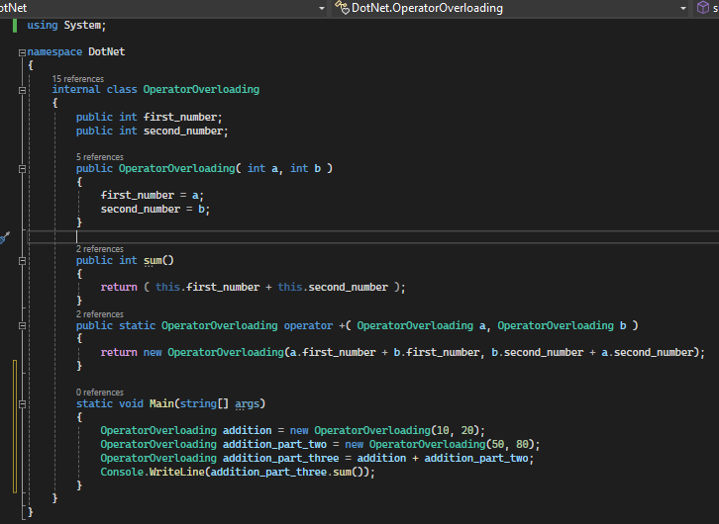

**Result**

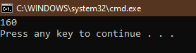

**Problem – 3**

Write a program to show the concept of multilevel inheritance and multiple inheritance in c#

**Code**

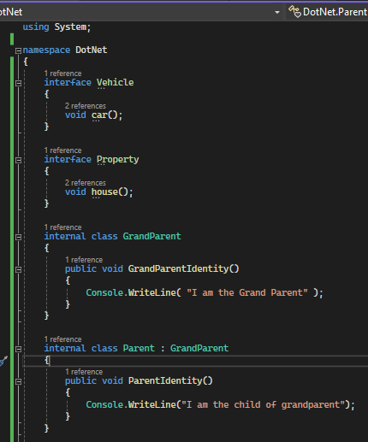

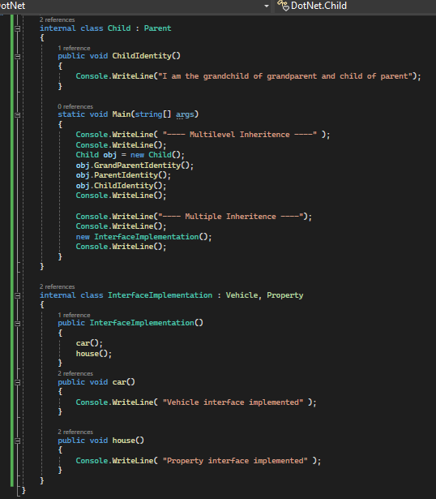

**Result**

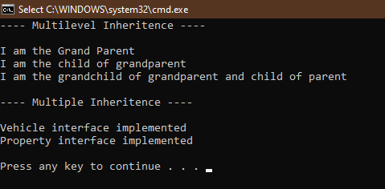**t**

**Problem – 4**

Write a program to on method overloading and method overriding in c#

**Code**

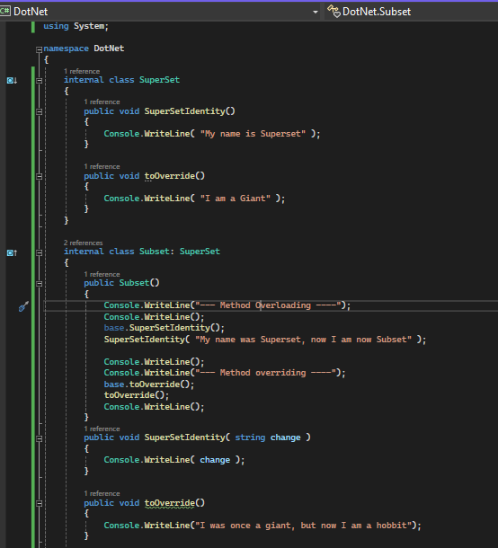

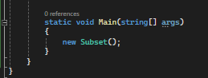

**Result**

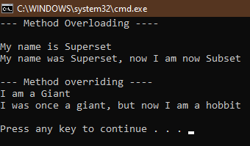

**Lab – 5**

Write a program to demonstrate the concepts of Delegates

**Code**

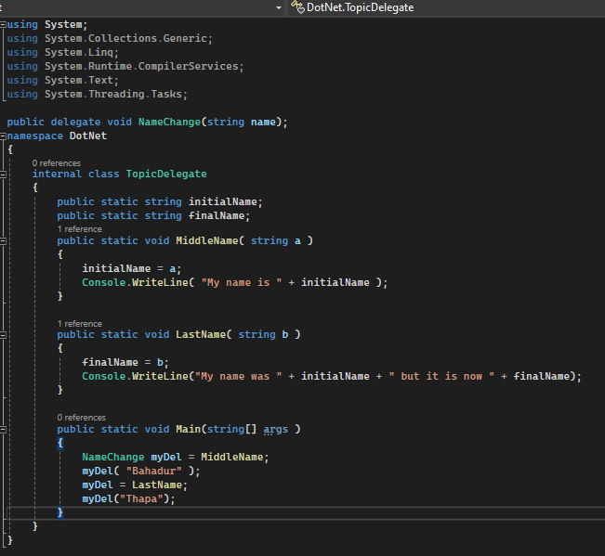

**Result**

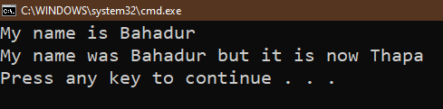

**Lab – 6**

Write a program to demonstrate the concepts of labels, text box and button controls.

**Code**

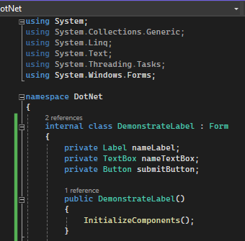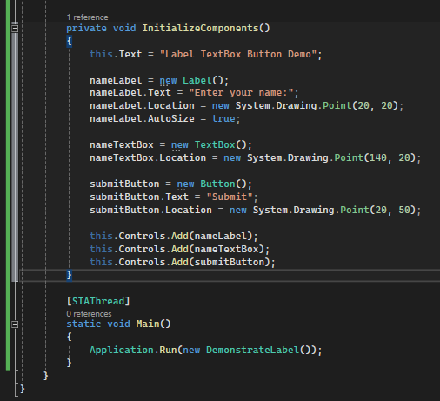

**Result**

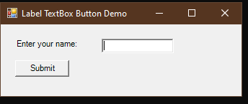

**Lab – 7**

Create a windows application in C# for registration form and fill the details and when you click the submit button it displays the details in the message box.

**Code**

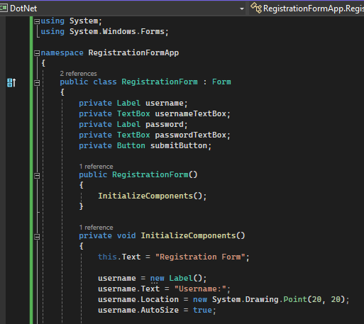

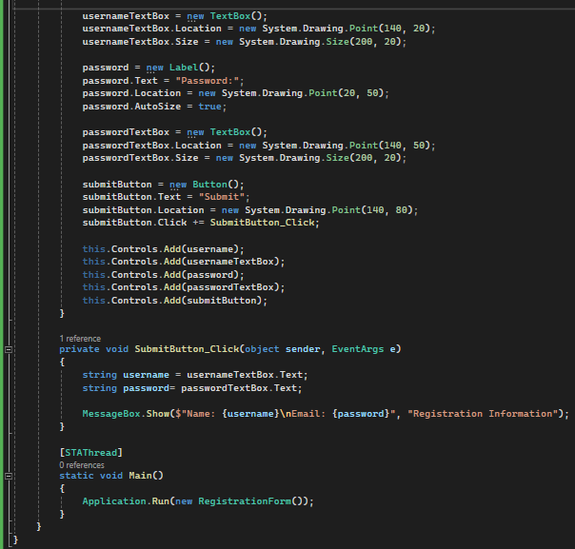

**Result**

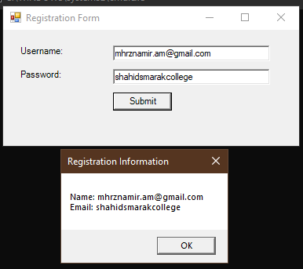

**Lab – 8**

Create a Windows application in C# having two text boxes and three buttons named as factorial, prime, factorial series. When you click any button, the resultant value will be displayed on the second textbox.

**Code**

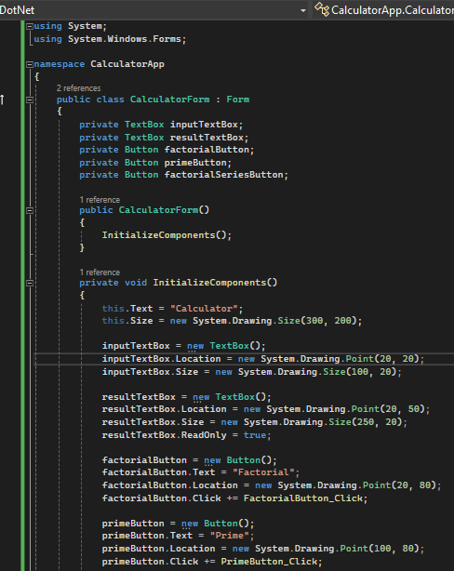

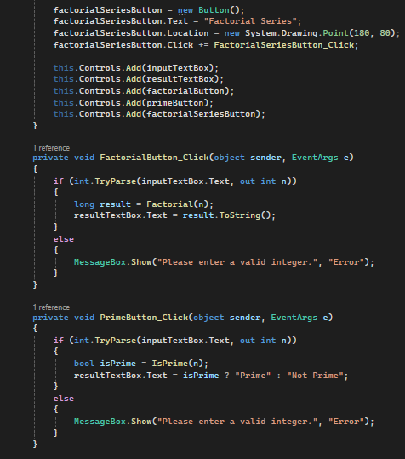

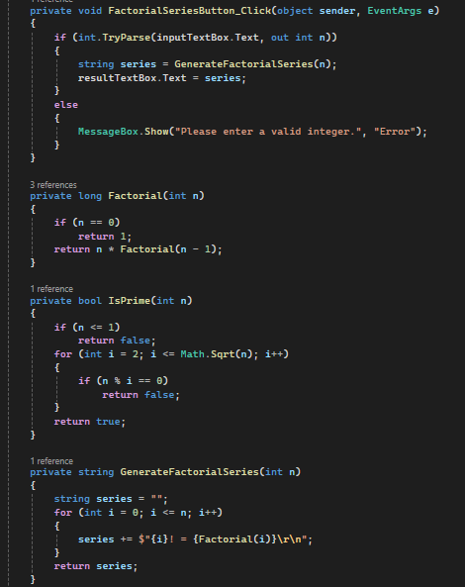

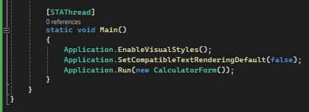

**Result**

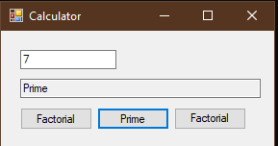

**Lab – 9**

Write a program to check whether the number is palindrome or not.

**Code**

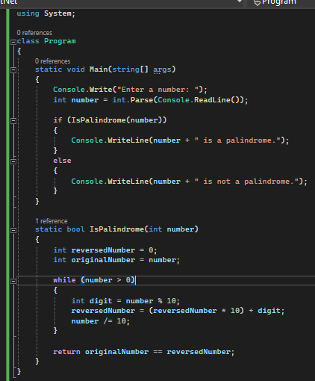

**Result**

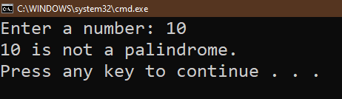

**Lab – 10**

Demonstrate exception handling.

**Code**

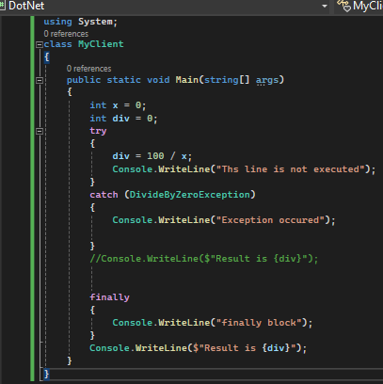

**Result**

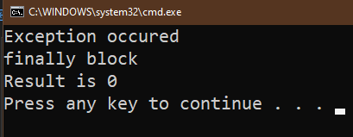

**Lab – 11**

Write a program to implement lambda Expression

**Code**

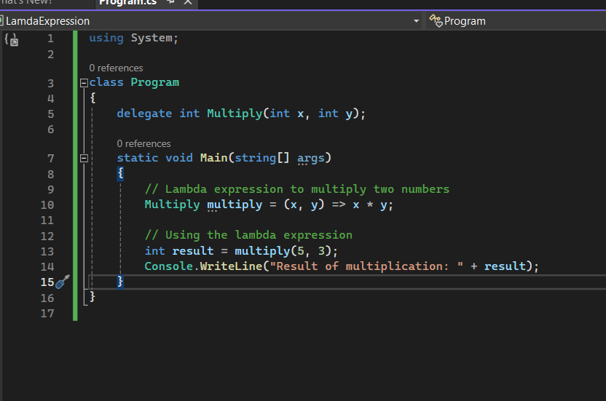

**Result**

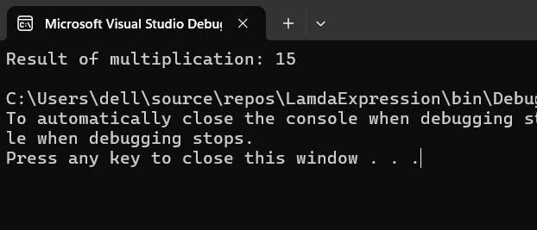

**Lab – 12**

Write a program to check whether the number is palindrome or not.

**Code**

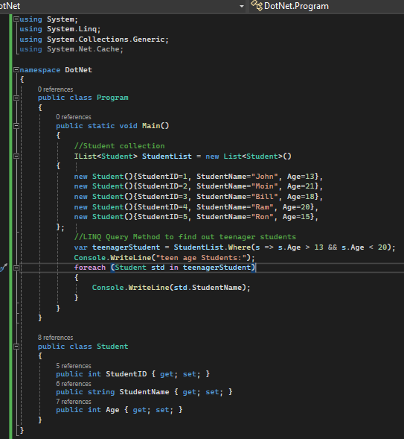

**Result**

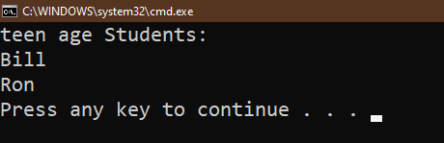

**Lab – 13**

Write a program to implement Generic class.

**Code**

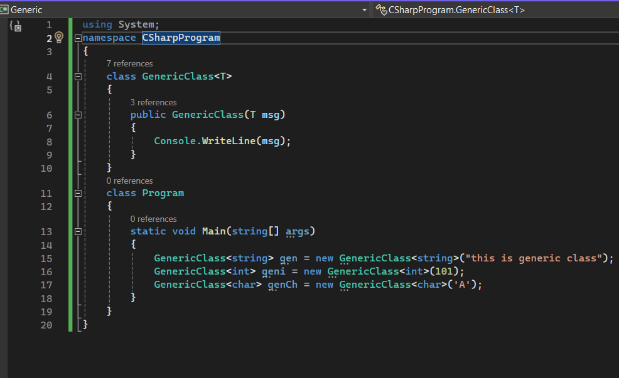

**Result**

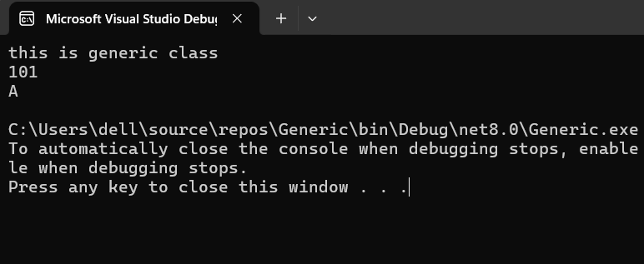

**Lab – 14**

WAP to find whether the input word is vowel or consonant.

**Code**

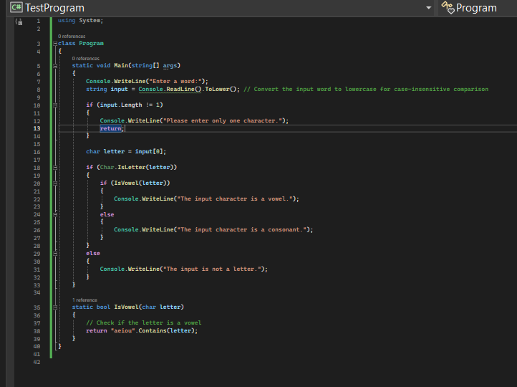

**Result**

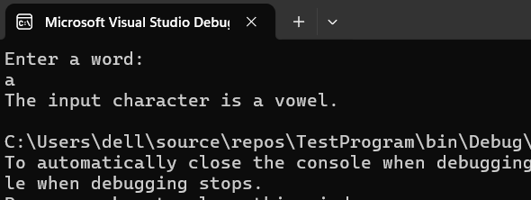

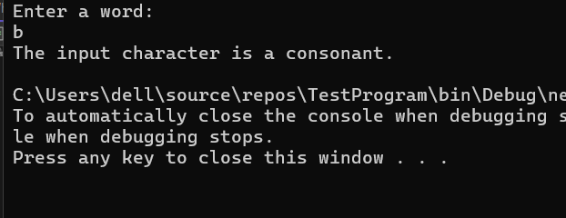

**Lab – 15**

WAP to implement the concept of destructors.

**Code**

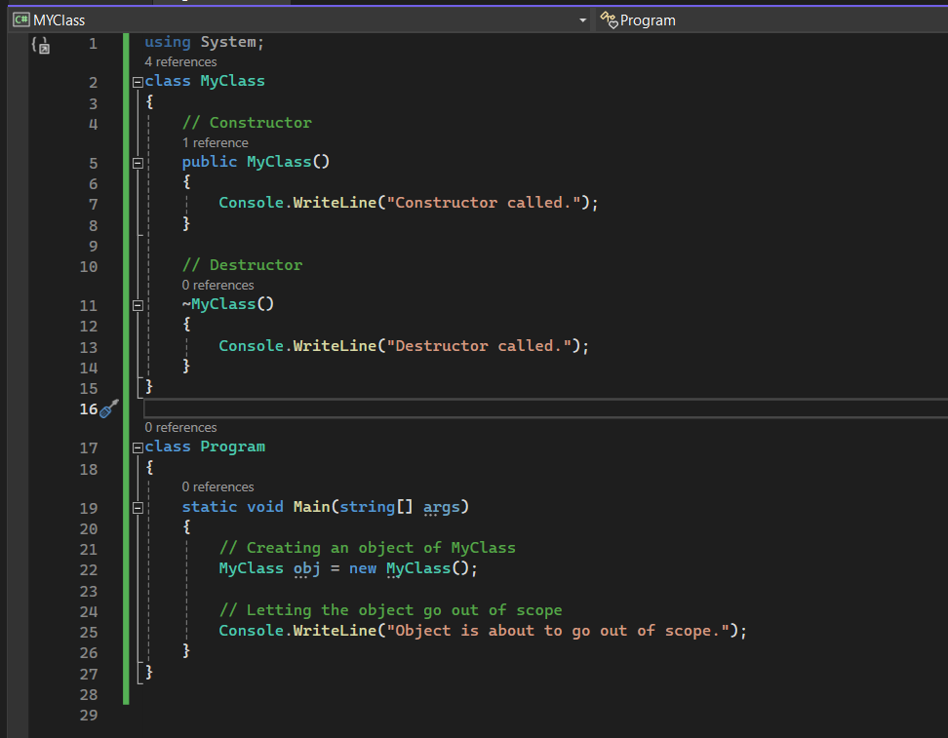

**Result**

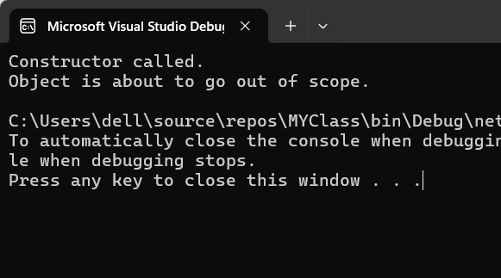

**Lab – 16**

WAP to check a number whether it is Armstrong or not.

**Code**

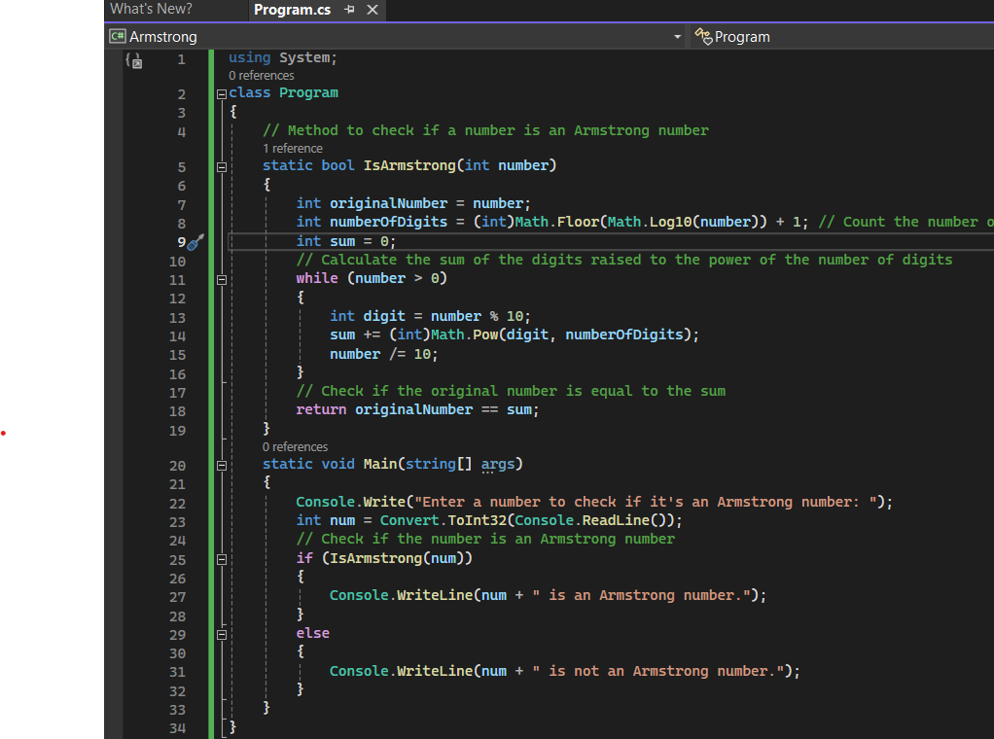

**Result**

